Foreword by Paul Peterson [College Counsellor & Psychotherapist]
We are probably all aware of the term ‘Mental Health’. We hear it everywhere now and naturally it has been highlighted even further since we have become aware of Covid-19 and the nation’s response to it. We can take a positive out of this by talking about our Mental Wellbeing helping to reduce the stigma that has been associated with it for far too long. Mental Health includes emotional, psychological and social wellbeing and affects our thoughts feelings and behaviours.
However, I want us to begin to use the term Mental-Wealth which I believe allows us to focus on the positive strategies, the things that we learn about ourselves to help us maintain our Mental Wellbeing. Think for a moment of finding a hidden Treasure Chest. Opening the chest reveals jewels of many colours, priceless in value and are now yours to keep and share. By coincidence you might find that just by having some of these jewels to hand will empower you in a number of ways. They will help;
- improve your relationships
- give you different ways to cope with some of life’s stresses
- you concentrate and work more effectively
- strengthen your resilience
- develop your self-awareness and self-worth
This will of course mean that family, friends and the community you invest in will also reap the rewards of your new found Mental-Wealth. You will begin to see yourself and others thrive as you ‘mirror’ the positive Mental-Wealth you have found. It will be a bit like walking into College for the first time and you see someone you don’t know, they smile and say “good-morning”. The likelihood is that you will smile back and answer with “good-morning” too. You see, it’s infectious in a good way.
So I want you to share your Mental-Wealth with people you meet by sharing the strategies [jewels] and resources [more jewels] you begin to learn about. Start by opening your treasure chest, grabbing some of those jewels for yourself and share them with others that you meet. Ask them about their day or if they are ok. Your enthusiasm and your positive Mind-set that you acquire will radiate your new found Mental-Wealth. Enjoy the journey and remember…”Not all Treasure is Silver and Gold, mate” (Capt. Jack Sparrow)

“It would be helpful for you to look over and make yourself familiar with this tool kit as part of your transition to Barnsley College. The tool kit will help you build your self-esteem, reduce anxiety including stress and help you to settle in. It might also be useful to add to your ongoing portfolio of work throughout your time at Barnsley College and you may find it could help with future career choices. Take a look at the Counselling page too where you can find resources and self-help cards to look at. This can be found on the Barnsley College main web page, click on Student Life, scroll down to Counselling and ‘hey-presto’, more jewels to add to your already bulging collection. You will also find cards on anxiety, depression, exam stress etc.”

Contents

Section 1
Foreword, introduction and contents index
Section 2
Anxiety, Stress & Worry
Section 3
Resilience
Section 4
Self-concept, self-esteem & self-efficacy
Section 5
Self-Awareness
Section 6
Sleep
Section 7
Chilypep
Section 8
Directory, Resources & Apps

What is anxiety, worry & stress? Section2
Everybody experiences anxiety and overall it is essential in making us alert and giving us an increase in adrenaline when we need it the most such as in emergency situations. However, when we believe there is a threat of danger we might become scared and fear is a normal reaction to something we call a ‘perceived threat’. Our coping mechanism might initiate the fight, flight responses to events we might see as overpowering or unavoidable.
Anxiety may also make us feel worried about the future. Thinking ahead can help us plan and cope but can also leave us with feelings of all or nothing thinking (if I don’t pass, I’ve ‘failed’ and won’t have the job I want). This kind of ‘all or nothing’ thinking can be unhelpful and can become excessive when it becomes persistent and uncontrollable, having ‘What-if’ thoughts and worst-case scenarios.
Stress is what we feel when we are under pressure, whether this is real or imagined and is completely normal and helpful as a way to help meet challenges, deadlines and keeps us focused in crisis situations. Nevertheless, too much stress can lead to feeling overwhelmed and if you have a tendency to get stressed frequently your body may exist in a heightened state of stress most of the time. This is when you might want to speak to someone like a counsellor or undertake steps to try to alleviate the stress you feel.
Remember, it is normal to be worried about starting College and have feelings of anxiety but it won’t last. You will get used to your College environment, the timetables, make new friends, and will be encouraged by your teachers and staff who are here to support you.
Let’s have a look at collecting some jewels (strategies) to help manage anxiety, stress and worry.
Strategies
Create a worry time – notice and limit your worries
Choose a set time each day for half an hour and ideally at the same time each day but not close to bedtime. You are going to give yourself permission during this set time to worry about whatever is on your mind and you might even come up with some solutions. Now, leave the rest of the day worry free.
For example if you think that you are not going to meet your course work deadline.
Possible solutions might consist of;
- You might ask for support from your teacher and create a timetable to complete work in bite size chunks
- You might tidy your bedroom to enable you to have a clear space to concentrate
- You might choose to put your phone in another room so you are not disturbed
The ‘Thoughts pdf’ below is a tool to help you examine your ‘Automatic Thoughts’ (AT) and then your Rational Thoughts (RT). AT are the thoughts that come to you in a ‘flash’ and may result in an irrational outcome.
E.g. you might be doing some food shopping in your local supermarket when you see your friend that you haven’t spoken to in a long while. You wave and say hi but your friend passes by without acknowledging you. Your AT might be “Mary ignored me, what have I done to her, why isn’t she my friend anymore.” Use the AT diary for a week or two to get used to writing in it and becoming aware of your AT.
Then when you have become comfortable writing your AT begin to use the RT diary to look for evidence against the irrational and negative AT.
E.g. you might say to yourself… “I can’t think I did anything wrong to Mary. I know her partner hasn’t been well and I wonder if her thoughts were elsewhere. I think I will ring her and check to see if she is ok.”
Watch your worries float away…. https://www.childline.org.uk/toolbox/games/balloon/
50 Ways to Combat Anxiety
https://www.barnsley.ac.uk/student-life/counselling/combating-anxiety/
Stress Resources
http://downloads.bbc.co.uk/safety/documents/health/health-stress-container-exercise.pdf http://www.yhscn.nhs.uk/media/PDFs/children/CYP%20Involve/Stairways-Coping-with-Stress-Booklet.pdf
What does anxiety, worry & stress mean to you? [Doodle space]
e.g. ‘I shut down when I have deadlines to meet’

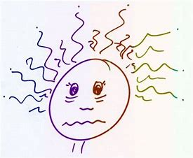

Resilience Section 3
To jump back, recoil and reform are the words I would use to describe resilience. Imagine you are a rubber band, events that happen to you, that make you feel stressed and uncomfortably overwhelmed will stretch you out of your original shape. The ability to respond in life with balance and composure helps to protect you by triggering your coping mechanisms. Being able to ‘spring-back’ to your original shape empowers you to take care of your mental wellbeing and once you have collected some new strategies (jewels) to do this, you will begin to add further to your Mental-Wealth.
What can you do to strengthen your resilience?
- Develop & maintain your resilience by taking care of yourself every day without a day off
E.g. “Come up with some ideas of how you might do this, for instance talk with someone who makes you feel happy and content with yourself, take a bubble bath and soak etc.”

- Sustain your self-esteem by being pro-active in actions that see yourself more positively. How might you achieve this?
E.g. “when someone gives you a compliment, say thank you and accept the ‘jewel’ the person has just given you of a ‘positive stroke’. You can then begin to reflect on these positive statements about yourself.”

- Be creative by expressing who you really are.
E.g. “take a photography class, write a poem, take up painting, redecorate your room in an original way, or consider making your own clothes.”

- Be active by becoming more physically fit. Now I’m not saying you have to become Mr or Mrs Universe, however we know about the connections between the mind and body so it makes sense if we are physically and mentally fit.
E.g. “Try starting simply by going for a 30-minute walk somewhere you enjoy.”

- Make peace with your past by confronting the hardships of the past, they may even continue to influence and direct your current responses. See these past issues as a chance to learn but don't expect this to happen overnight, however, the end result will be a far more resilient self.
E.g. “You might consider Journaling to think about past setbacks, about what happened and what you learned from it (what worked and what didn’t work) can help you come to terms with the past. Talk to a therapist, a counsellor, or your doctor if you cannot work through past issues alone. If you feel like you're missing closure on an event from your past, try to figure out what it will take to move on? It might mean you will need to confront someone, something or go someplace where you lived before but remember it isn’t always possible to get the closure you want but you may learn to think about it differently and feel stronger when faced with similar events.”
8 Magical Benefits of Resilience http://entm.ag/ls5
It might be a good idea to work through this check list when faced with a problem and help
increase your chances of becoming more resilient.
1) Understand the problem.
2) Make a list (find more than one solution to the problem) of pro’s & con’s.
3) Put the chosen solution into Action (assess the action and don’t be afraid if it doesn’t work, it’s a learning experience).
What does Resilience mean to you? [Doodle space]
E.g. ‘I have had a test in maths and didn’t get the grade I was hoping for…ok so I can do some revision and do better next time’

Self-concept, self-esteem, self-worth, self-efficacy Section 4 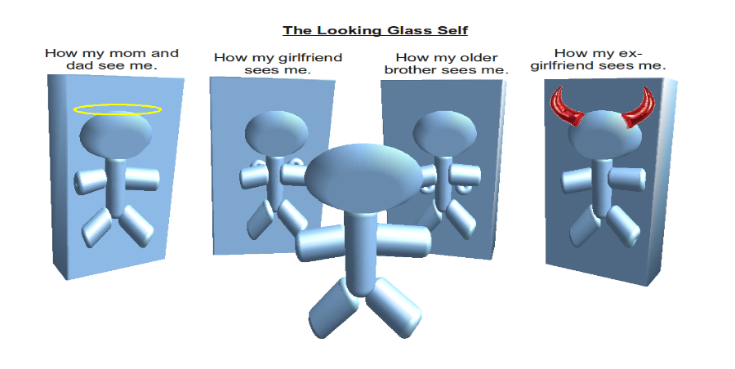
The self-concept explains how any individual see’s themselves incorporating the positive and negative assessments on how we think and feel about it.

Self-esteem just means how we measure our own self-worth and self-efficacy stems from the beliefs and on how well it may affect the ability of the person to achieve their goals.
Low self-esteem usually begins in childhood growing up with disapproval and the individual may take this with them through school, maybe through a dysfunctional workplace and on into adult life. People who have a poor self-concept or worth may stay in abusive relationships, be depressed or have another form of mental health concern.
We are all individuals, we are not the same as the next person so when the worlds media describes what success looks like, try not to buy into it too much. Not having that high paid job, the particular car, or an expected ideal family doesn’t mean you are not successful and doesn’t mean you are worthless without all of the above. Set your own goals and strive for self-efficacy. Don’t follow someone else’s dream but follow your own dream. Take note of your ‘inner-compass’ as your journey may be different, might well be longer, be more scenic and may even be more fulfilling for you.

Self-Esteem resources
Keep notes in a gratitude jar
Write down what you are grateful for, this could be anything from something that made you smile or you enjoyed etc. and put the notes in a gratitude jar. You can keep adding notes over time. Every so often before bed take the notes out and have a read over them. A gratitude jar can be a good visual reminder on bad days that you have lots to be grateful for.
A week’s worth of gratitude journaling. Print several weeks’ worth of sheets (try a month to begin with) and fill out each one by the end of your day.
Print out one for each day (try a month to begin with) and circle which words you associate with yourself today. Tip; Listen to compliments that people give you to identify words to circle.
Print out one for each day (try a month to begin with) and fill it out at the end of the day. Don’t rush, so don’t do this 5 minutes before bed but do fill it out fully.
“You have to create an ATTITUDE for GRATITUDE” Bob Mortimer. Mortimer & Whitehouse in Gone Fishing. S3, E1 23/08/20
What does Self-concept, self-esteem, self-worth, and self-efficacy mean to you? [Doodle space]
i.e. ‘I won’t compare myself to others on social media sites I use’

Self-Awareness Section 5
Of these thoughts 80% are negative

95% are exactly the same as the day before
Research shows we have between 12,000-70,000 thoughts a day!

As well as this, 85% of what we worry about actually never happens and even if it does happen it is more than likely not as bad as you imagined.

Most of these thoughts arise in our mind on auto pilot, often without warning. This can then lead us down a winding path that might make us anxious, upset and worry more than usual. The good news is that there are ways you can help manage your thoughts. By becoming more self-aware and by recognising these [thoughts] you will be more tuned in to your own self and can then look at strategies (jewels) to maintain a more positive way of being.
Let us look at some strategies that can help manage our mind:
Focus on the positive
Positive Thinking - can help you become more optimistic which can result in you feeling happier, reduce anxiety and your stress levels. So how can we do this?
Pay attention and notice positive parts of your day. Often our brain focuses on the negative and this can cloud our mind. A good starting point to help with this is to practice gratitude. Before bed each night use the gratitude journal above ..\Documents\Gratitude Journal 3 Good Things.pdf (section 4) to observe what you have been grateful for, made you smile that day and lifted your mood. This could be something simple like someone saying hello to you or receiving a text from a friend you have not heard from in a while. Often if you feel you have had a bad day or week, you can look back over these positive moments to help you balance your mind.
Savouring
Another technique is to savour the good moments. Often we let good times pass by without truly enjoying these. This is where ‘mindfulness’ can come in. If you are on a walk and something catches your eye, such as the beauty of nature or bird song then come into the present moment and just think about this and appreciate it.
Goal setting
Goal setting is a great way to motivate your day and by doing so it will improve your focus and productivity. Goal setting allows you to stay focused on your goals and looks for ways to achieve them. Remember to use the SMART way of goal setting;
- Specific = significant
- Measurable = motivating
- Achievable = attainable
- Relevant = realistic
- Timely = time limited
All you need to do is write down a goal you want to achieve that day and make it SMART.
‘Find Your Headspace’
When you start college, the college will be holding weekly meditation sessions via Teams. For more information contact l.kelly@barnsley.ac.uk
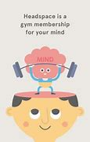
Useful Resources:
https://www.mentallyhealthyschools.org.uk/media/2013/self-care-kit-covid-19.pdf
http://www.freemindfulness.org/
https://youngminds.org.uk/media/2900/hope-clouds-activity.pdf
Sleep Section 6
Sleep plays an important role in your Mental-Wealth. Sleeping allows your body to rejuvenate, repair, as well as giving your brain time to process memories and information. It is vital for mental and physical health.
Have a look at CHILYPEP’s Sleep Tool Kit it will give you a better understanding of why sleep is important, as well as strategies and tips on how to get a good night’s sleep.
https://www.chilypep.org.uk/uploads/CHIL%20sleep%20toolkit%20FINAL.pdf
Further tips: You may also find listening to Solfeggio Frequencies or Binaural Beats https://www.youtube.com/watch?v=S3F0no7euEU before bed may help you fall asleep. If you search YouTube there are lots of free ones to listen to.

You can also have a look at some other useful websites below:
https://www.childline.org.uk/info-advice/your-feelings/feelings-emotions/problems-sleeping/
https://www.nhs.uk/live-well/sleep-and-tiredness/how-to-get-to-sleep/
https://www.nhs.uk/live-well/sleep-and-tiredness/sleep-tips-for-teenagers/
https://web.ntw.nhs.uk/selfhelp/leaflets/Sleeping%20Problems.pdf
Apps
HeadSpace (free for students with a full student Spotify account)
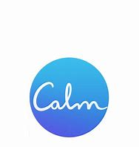 Calm
Pzizz (free in app purchases)

Chilypep Section 7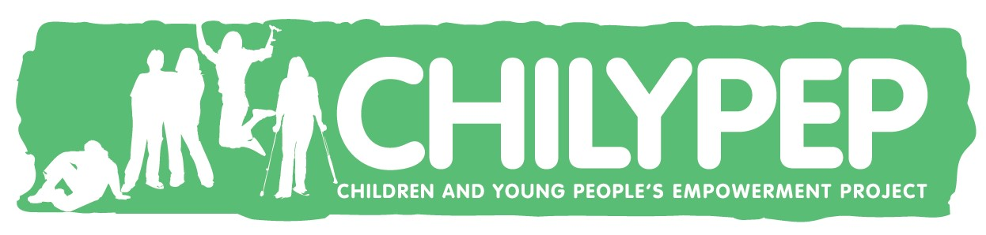
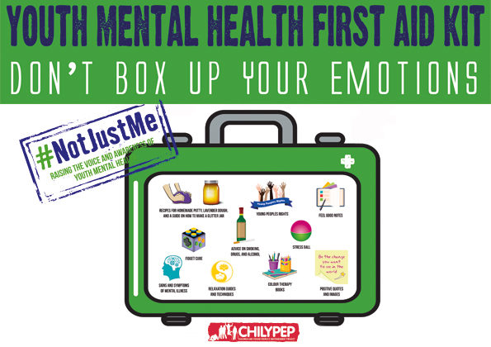
The Children and Young Peoples Empowerment Project have developed a ‘Mental Health First Aid Kit’. The idea behind the kit is to provide a number of coping strategies to support emotional wellbeing. Click on the link below and have a look. Why not have ago at some of the activities included.
https://www.chilypep.org.uk/uploads/Chilypep%20Mental%20Health%20First%20Aid%20Kit%20May%202020.pdf
CHILYPEP’s Peer Mentor and Mentee Programme
Peer Mentoring – Do you want to help other learners settle into college and raise awareness around mental health? If so, sign up to become a Peer Mentor with CHILYPEP
Peer Mentees – If you are struggling to cope, with the transition or just need someone to talk to, you can be matched with one of CHILYPEP’s trained Peer Mentors for support while you are in college.
Contact emma.manser@chilypep.org.uk for more information
Chilypep’s Mental Health Passport Tool
The young commissioners at STAMP (Support, Think, Act, Motivate, and Participate) Group with Chilypep have developed a ‘Mental Health Passport’. This is a confidential database developed between Chilypep and NHS England that can be used for you to record ‘Your Story’. The Governments “Future in Mind’ report examined how young people’s mental health should be provided for, stating… “you should only have to tell your story once, to someone who is dedicated to helping you, and you shouldn’t have to repeat it to lots of different people”
https://assets.publishing.service.gov.uk/government/uploads/system/uploads/attachment_data/file/414024/Childrens_Mental_Health.pdf
The information is about you, in your own words and you choose who you want to share the information with.
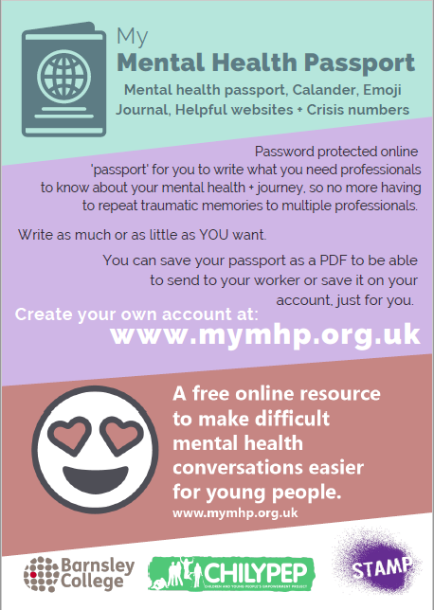
“Changes, older ages, ​
New staff and new faces, ​
Lost in the system, ​
Transitions and unknowns, ​
Sometimes it feels like you’re all alone, ​
Learning new things and reliving the old, ​
Sick of repeating a story that’s been told, ​
Growing up and learning, ​
Trying a new, ​
Finding your voice, ​
And what it means to be you.”
​Robyn Beighton, 24

Directory Section 8
Contact Numbers

- Barnsley College -The Health and Wellbeing Centre 01226 216233
Open 8.30am-5pm Mon-Thurs and 8.30 – 4.30pm Fri
- The Samaritans 116123 www.samaritns.org email: jo@samaritans.org
Open 24/7 365 days https://www.samaritans.org/
- Papyrus Suicide Prevention (Hopeline UK) 0800 068 4141
Open 9am-10pm weekdays 2pm-10pm weekends and Bank Holidays https://papyrus-uk.org/
- Shout – text ‘shout’ to 85258 for 24/7 crisis text support
- Childline – under 19s can call 0800 111 for free support or 1-2-1 counsellor chat online
https://www.childline.org.uk/get-support/contacting-childline/

Resources
- Mind Space
https://wearemindspace.com/
- Young Minds
https://youngminds.org.uk/
- Mood Juice
https://www.moodjuice.scot.nhs.uk/professional/pdfGuides.asp
- Every Mind Matters- Get Your Mind Plan
https://www.nhs.uk/oneyou/every-mind-matters/your-mind-plan-quiz
- CAMHS Resources
https://www.camhs-resources.co.uk/
- ‘Open Up Barnsley’ is your guide to emotional wellbeing and mental health support for all children and young people in Barnsley
https://www.chilypep.org.uk/uploads/Updated%20Open%20Up%20Barnsley%20Directory%202019.pdf
- ‘Let’s Talk Sheffield’ is your guide to emotional wellbeing and mental health support for all children and young people in Barnsley
https://www.sheffieldccg.nhs.uk/Downloads/Our%20Projects/Childrens/lets%20talk.pdf
- Uni Head is a free training package on how to look after your mental health and how to support a friend - for college students
https://uniheads.co.uk/students/

Apps
Think Ninja - Think Ninja is an app specifically designed to educate 10-18 year olds about mental health, emotional wellbeing and to provide skills young people can use to build resilience and stay well.
Smiling Mind – Developed by phycologists and educators to help incorporate mindfulness into your life
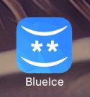
BlueIce – Is a evidenced-based app to help young people manage their emotions and reduce urges to self-harm

Catch It – Learn how to manage feelings such as anxiety and depression. The app will teach you to look at problems in a different way, turn negative thoughts into positive ones and improve your mental wellbeing
Chill Panda – Learn to relax, mange your worries and improve your wellbeing. The app includes simple breathing techniques and light exercises to take you mind off your worries.

Cove- Music for mental health. Create music to capture your mood and express how you feel.
Worry Tree – Uses cognitive techniques to help you notice and challenge your worries

Available Support in College
All therapeutic support referrals are done through the SPA (Single Point of Access) Referral form. This can be completed as a self-referral or you can speak to your tutor to support you to complete this. The form is available on Moodle..\Desktop\SPA Form 2.docx

At Barnsley College we have access to:
- Counselling Service with a qualified Counsellor and Child & Adolescent Psychotherapist https://www.barnsley.ac.uk/student-life/counselling/
- IAPT (Improving Access to Psychological Therapies)
- Weekly online Mindfulness Sessions (Contact the Health and Wellbeing Centre for more info)
- Wellbeing Wednesday (wellbeing support activities)
- Referral pathway into other services and agencies
Many thanks
This document has been a collaboration between Lisa Kelly (Health & Wellbeing Advisor) and Paul Peterson (Counsellor, Child & Adolescent Psychotherapist) from the Student Services department at Barnsley College.
This Mental-Wealth work book aims to help reduce the stigma associated with Mental Health and the services employed to care for anyone who is either directly and/or indirectly affected by mental health concerns. We wanted to change the way Mental Health sounds and feels so began to use the expression Mental-Wealth as a more positive affirmation and the more you know, the more jewels you acquire, the more you will have a positive outlook towards your Mental-Wealth and wellbeing.
We have shared some strategies that we have experienced as being helpful for some people but also appreciate that ‘one size does not fit all’. However, we hope you begin to use some of the approaches we have shared with you and begin using the collection of strategies or jewels along with the new approach to Mental-Wealth, hopefully enriching all our lives.
We would also like to invite anyone to share what works for them, the jewels they have collected that enrich and help manage their daily life and hope you begin collecting jewels either for yourself or someone you know who may benefit from the shared awareness. You can do this by contacting Toodles at HWBC@barnsley.ac.uk Our hope is that it will soon elevate the way you and those that you come into contact with see Mental-Wealth in the future.
Many thanks for taking the time to read through and hopefully put into practice your own Mental-Wealth sharing.
Lisa and Paul

