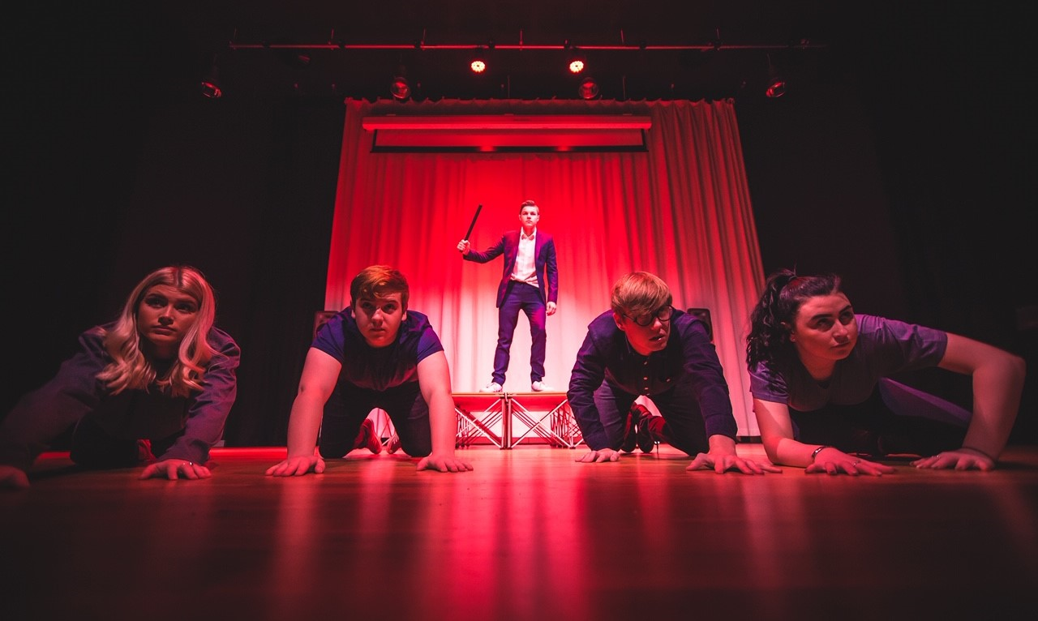
A-LEVEL DRAMA AND THEATRE STUDIES
Please complete all the following tasks listed below for each component:

Component 1: Theatre Review

Tasks:
1) Watch a piece of theatre (can be a past one you have seen or can be one from either Digital Theatre or National Theatre's YouTube Page).
2) Pick an actor from that production, who you thought successfully portrayed their character well.
3) Take notes from 2 scenes on how the actor used their performance skills (voice, facial expressions, movement, gestures, and interactions) to successfully communicate meaning to the audience.
4) Write two paragraphs (approx 500) words answering the following question: Analyse how the performer successfully used their performance skills to effectively communicate meaning to an audience?

Component 2: Mood Board

Task:
Create a mood board on a variety of topics within society you are interested in with images, quotes, bits of text etc.
You may wish to talk about things that are relevant or interesting to you i.e. Latest news headlines, technology, art, books, films, religion.

Past Examples:
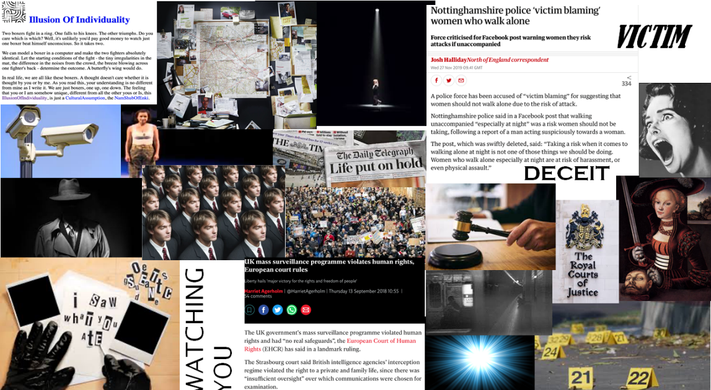

Component 3: Practitioner Research

Tasks:
1) Create a poster or mind map on ONE of the two practitioner's listed below:
Konstantin Stanislavski
Bertolt Brecht

2) You will need to include information about; their life, their style of theatre, their techniques and how their methods are used in modern theatre.

3) Please ensure you copy and paste all websites links used onto a separate page.

If you have any questions on the tasks set please contact; s.walker@barnsley.ac.uk

