Pre-enrolment task: A Level Biology 2021
Print if possible or answer on separate paper. Complete all 8 questions to the best of your ability, you may research your answers using text books and/or the internet but all work MUST be written in your own words. You may use a calculator for calculations but please show your working out.
Bring to your first Biology lesson.
- Research the structure of the biological molecules: Carbohydrates, Proteins, lipids and nucleic acids. Use the table below to summarise your research:

Biological Molecule | Name and draw structure of a monomer (single unit) | Name of bond joining monomers | Examples found in the human body | Functions/further information
Carbohydrates

Lipids

Proteins

Nucleic Acids

2. What is a stem cell? Explain and describe some potential uses of stem cells in medicine?
……………………………………………………………………………………………………………………………………………………………
……………………………………………………………………………………………………………………………………………………………
……………………………………………………………………………………………………………………………………………………………
……………………………………………………………………………………………………………………………………………………………
……………………………………………………………………………………………………………………………………………………………
……………………………………………………………………………………………………………………………………………………………
……………………………………………………………………………………………………………………………………………………………
……………………………………………………………………………………………………………………………………………………………
……………………………………………………………………………………………………………………………………………………………
……………………………………………………………………………………………………………………………………………………………
……………………………………………………………………………………………………………………………………………………………
……………………………………………………………………………………………………………………………………………………………
…………………………………………………………………………………………………………….(attach extra sheets if needed)

3. Explain how a vaccination can provide protection from infectious disease.
……………………………………………………………………………………………………………………………………………………………
……………………………………………………………………………………………………………………………………………………………
……………………………………………………………………………………………………………………………………………………………
……………………………………………………………………………………………………………………………………………………………
……………………………………………………………………………………………………………………………………………………………
……………………………………………………………………………………………………………………………………………………………
……………………………………………………………………………………………………………………………………………………………
……………………………………………………………………………………………………………………………………………………………
……………………………………………………………………………………………………………………………………………………………
……………………………………………………………………………………………………………………………………………………………
……………………………………………………………………………………………………………………………………………………………
……………………………………………………………………………………………………………………………………………………………
…………………………………………………………………………………………………………….(attach extra sheets if needed)

4.
Biological washing powders contain enzymes which hydrolyse substances that cause stains on clothes.
A manufacturer tested the ability of two types of the same brand of washing powder to remove different food substances that stain clothes.
• Type A contained an enzyme.
• Type B was identical to A except it did not contain the enzyme.
Figure 1 shows the results.
Figure 1
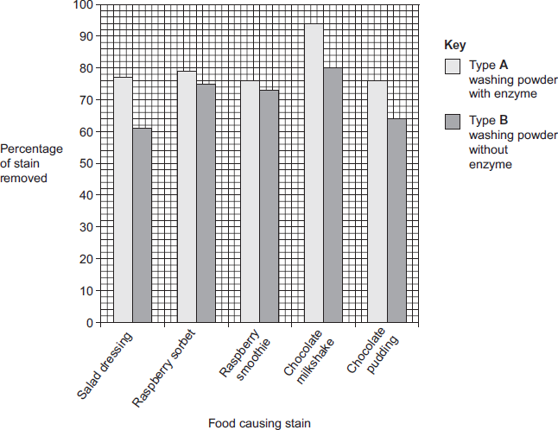
A scientist worked for a company that wanted to develop a biological washing powder that was effective over a range of temperatures. He investigated the effect of temperature on the rates of the reaction catalysed by two enzymes, P and S used in biological washing powders.
Figure 2 shows his results.

Figure 2
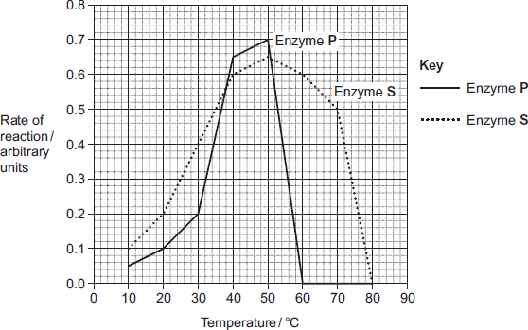
(a) Many of the substances causing the food stains are large, insoluble proteins.
Suggest how a biological washing powder removes this type of stain.
___________________________________________________________
___________________________________________________________
___________________________________________________________
___________________________________________________________
___________________________________________________________
(2)
(b) The manufacturer of type A and type B washing powder claimed that these results showed that biological washing powders are better at removing stains from clothes.
Use the information in Figure 1 to evaluate this claim.
___________________________________________________________
___________________________________________________________
___________________________________________________________
___________________________________________________________
___________________________________________________________
___________________________________________________________
___________________________________________________________
(4)
(c) Most customers want a washing powder which removes stains from clothes over a range of temperatures. After obtaining the results shown in Figure 2, which enzyme should the scientist recommend for use in a biological powder?
Give reasons for your answer.
___________________________________________________________
___________________________________________________________
___________________________________________________________
___________________________________________________________
___________________________________________________________
___________________________________________________________
(3)
(d) Biological washing powders often contain a number of different enzymes. This enables them to remove a wider range of stains from clothes.
Explain why a number of enzymes are required to remove a wider range of stains.
___________________________________________________________
___________________________________________________________
___________________________________________________________
___________________________________________________________
___________________________________________________________
___________________________________________________________
(3)
(Total 12 marks)

5. Large insects contract muscles associated with the abdomen to force air in and out of their bodies through small holes called spiracles. This is known as ‘abdominal pumping’. The table shows the mean rate of abdominal pumping of an insect before and during flight.

Stage of flight | Mean rate of abdominal pumping/dm³ of air kg⁻¹ hour⁻¹
Before | 42
During | 186

(a) Calculate the percentage increase in the rate of abdominal pumping before and during flight. Show your working.

Answer ____________________ %

Spiracles are able to open and close in response to differing environmental conditions. The graph shows the concentration of oxygen inside an insect (in tubes called tracheoles) when at rest. It also shows when the spiracles are fully open.

.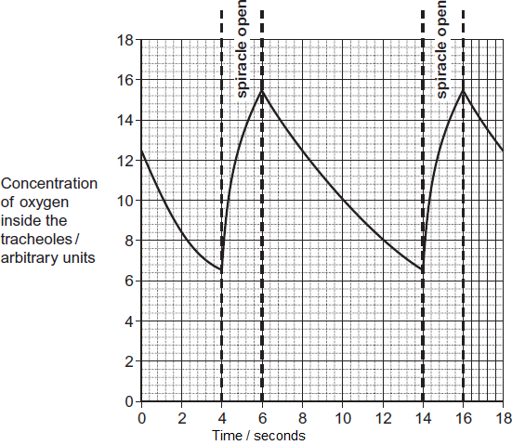

(b) Use the graph to calculate the frequency of spiracle opening. Show your working.

Frequency ____________________ times per minute (2)

6. The diagram shows a cross-section of an artery.

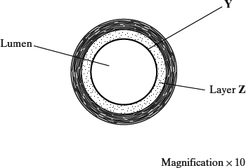

(a) What type of tissue is in the layer labelled Y?

___________________________________________________________

(1)

(b) Layer Z contains a high proportion of elastic tissue.

Describe the advantage of having elastic tissue in the wall of an artery.

___________________________________________________________

___________________________________________________________

___________________________________________________________

___________________________________________________________

(2)

(c) Calculate the cross-sectional area of the lumen of the artery shown in the diagram. Show your working.

The area of a circle is given by πr², where r is the radius of a circle (π = 3.14).

Answer ____________________ mm²

(3)

(Total 6 marks)

7. Describe and explain how exchange of oxygen and carbon dioxide occurs at the gas exchange surface in the lungs.
……………………………………………………………………………………………………………………………………………………………
……………………………………………………………………………………………………………………………………………………………
……………………………………………………………………………………………………………………………………………………………
……………………………………………………………………………………………………………………………………………………………
……………………………………………………………………………………………………………………………………………………………
……………………………………………………………………………………………………………………………………………………………
……………………………………………………………………………………………………………………………………………………………
……………………………………………………………………………………………………………………………………………………………
……………………………………………………………………………………………………………………………………………………………
……………………………………………………………………………………………………………………………………………………………
……………………………………………………………………………………………………………………………………………………………
……………………………………………………………………………………………………………………………………………………………
…………………………………………………………………………………………………………….(attach extra sheets if needed)

8. Short essay question to be completed on separate paper:
Describe and explain how DNA is linked to the physical characteristics an organism has.

