Name……………………………………………
Applied Diploma Medical Science: Induction Task
Hand in the induction task to your Medical Science tutor during your first lesson in September

Task 1. Fully review all your GCSE Science notes (if you can, also use: text books, revision guides and/or online revision sites), paying particular attention to biology topics. You will need to have thorough knowledge and understanding of GCSE Science to give you a good grounding in this subject.

Task 2. Complete ALL questions below, you may use a calculator.

a) What is a stem cell? Explain and describe some potential uses of stem cells in medicine?
……………………………………………………………………………………………………………………………………………………………
……………………………………………………………………………………………………………………………………………………………
……………………………………………………………………………………………………………………………………………………………
……………………………………………………………………………………………………………………………………………………………
……………………………………………………………………………………………………………………………………………………………
……………………………………………………………………………………………………………………………………………………………
……………………………………………………………………………………………………………………………………………………………
……………………………………………………………………………………………………………………………………………………………
……………………………………………………………………………………………………………………………………………………………
……………………………………………………………………………………………………………………………………………………………
……………………………………………………………………………………………………………………………………………………………
……………………………………………………………………………………………………………………………………………………………
…………………………………………………………………………………………………………….(attach extra sheets if needed)

b) Explain how a vaccination can provide protection from infectious disease.
……………………………………………………………………………………………………………………………………………………………
……………………………………………………………………………………………………………………………………………………………
……………………………………………………………………………………………………………………………………………………………
……………………………………………………………………………………………………………………………………………………………
……………………………………………………………………………………………………………………………………………………………
……………………………………………………………………………………………………………………………………………………………
……………………………………………………………………………………………………………………………………………………………
……………………………………………………………………………………………………………………………………………………………
……………………………………………………………………………………………………………………………………………………………
……………………………………………………………………………………………………………………………………………………………
……………………………………………………………………………………………………………………………………………………………
……………………………………………………………………………………………………………………………………………………………
…………………………………………………………………………………………………………….(attach extra sheets if needed)

c) The diagram shows a cross-section of an artery.

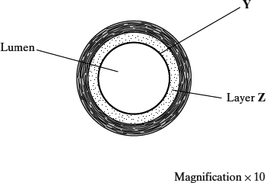

(a) What type of tissue is in the layer labelled Y?

___________________________________________________________

(1)

(b) Layer Z contains a high proportion of elastic tissue.

Describe the advantage of having elastic tissue in the wall of an artery.

___________________________________________________________

___________________________________________________________

___________________________________________________________

___________________________________________________________

(2)

(c) Calculate the cross-sectional area of the lumen of the artery shown in the diagram. Show your working.

The area of a circle is given by πr², where r is the radius of a circle (π = 3.14).

Answer ____________________ mm²

(3)

(Total 6 marks)

d) Describe and explain how exchange of oxygen and carbon dioxide occurs at the gas exchange surface in the lungs.
……………………………………………………………………………………………………………………………………………………………
……………………………………………………………………………………………………………………………………………………………
……………………………………………………………………………………………………………………………………………………………
……………………………………………………………………………………………………………………………………………………………
……………………………………………………………………………………………………………………………………………………………
……………………………………………………………………………………………………………………………………………………………
……………………………………………………………………………………………………………………………………………………………
……………………………………………………………………………………………………………………………………………………………
……………………………………………………………………………………………………………………………………………………………
……………………………………………………………………………………………………………………………………………………………
……………………………………………………………………………………………………………………………………………………………
…………………………………………………………………………………………………………….(attach extra sheets if needed)

e) A research scientist investigated the effect of caffeine on heart rate in human volunteers.

The scientist divided volunteers into three groups. Each group was given the same volume of fluid.

• Each member of Group I was given a sports drink containing caffeine and sugar.

• Each member of Group J was given a sports drink containing caffeine and no sugar.

• Each member of Group K was given water.

The scientist recorded the volunteers’ heart rate before the drink was given and for 120 minutes after the drink was given.

Her results can be seen in Figure 2.

Figure 2

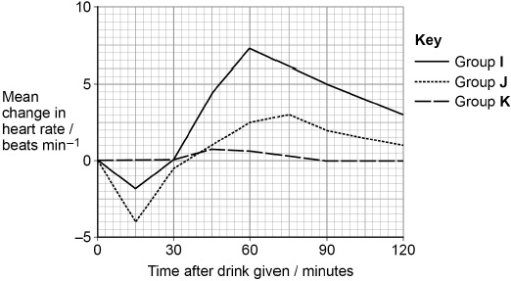

(i) Caffeine affects the autonomic nervous system.

Suggest how caffeine could account for the results of Group I in Figure 2 at 60 minutes.

___________________________________________________________

___________________________________________________________

___________________________________________________________

___________________________________________________________

___________________________________________________________

___________________________________________________________

________________________________________________________(2)

(ii) Before taking the drink, the mean heart rate of Group J was 68 beats per minute.

Fifteen minutes after taking the drink, the mean volume of blood leaving the hearts of Group J was 4700 cm³ per minute.

Calculate the mean volume of blood leaving the heart at each beat fifteen minutes after taking the drink.

Answer = ___________________________ cm³

(1)

Task 3. Essay: Read about current health topics on the BBC news website here:
- https://www.bbc.co.uk/news/health
- Choose one article and write a report summarizing the details in your own words (hand written please)
- Reference with the article title and web link.

