A Level Biology: Preparation & Induction Tasks
Induction task to be handed in at your first Biology lesson in September

Preparation work
1. Fully review all your GCSE Science notes, paying particular attention to biology and any topics that weren’t taught or finished at school due to COVID19. We recommend using:
https://www.bbc.co.uk/bitesize/examspecs/zpgcbk7
2. We also recommend using the link below to read through the Biology notes sections and then attempt the questions at the end of each topic. This will give you a good taster of some of the main topics that will be taught in A Level Biology as well as building on the skills you will need to succeed.
http://fdslive.oup.com/www.oup.com/oxed/secondary/science/Science_A_Level_Transition_Pack_Biology.pdf
(This is your preparation work, you do not need to submit anything to us)

Induction Task
- Complete the following questions and hand in to a Biology tutor during your first lesson in September
Print this document if possible or write your answers on paper if printing is not possible.
- a) Name structure A in the animal cell………………………… (1)

- What process occurs here? ……………………………….. ……………………………………………… (1)

- Write the chemical equation for this process (1):
……………………………………………………………………………………………………………………………………………………

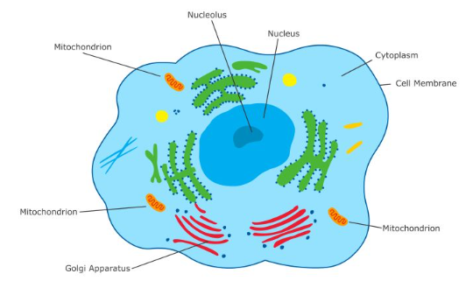
C
B
A

- If the line B C measures 10 µm, what is the magnification of the diagram?. Show your working. (2)

……………………………….

. 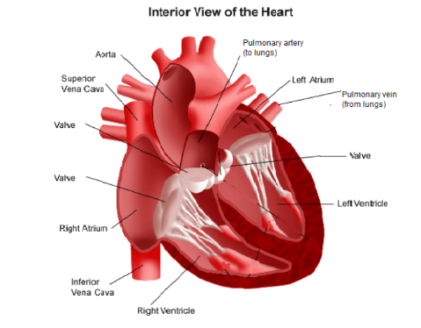
2a. The diagram shows a cross-section of the human heart. Describe the sequence of how blood moves through the blood vessels and chambers (2).
………………………………………………………………………………………………………………………………………………………
………………………………………………………………………………………………………………………………………………………
………………………………………………………………………………………………………………………………………………………

b. Which chamber produces the highest pressure when it contracts? Explain why this high pressure is needed (2).
………………………………………………………………………………………………………………………………………………………
………………………………………………………………………………………………………………………………………………………
………………………………………………………………………………………………………………………………………………………

2c. One type of cardiovascular disease is called SVCS. This condition is very serious as it obstructs blood flow going to the heart. Which type of blood vessel (artery, vein or blood capillary) will it affect? Give a reason for your answer. (2).
………………………………………………………………………………………………………………………………………………………
………………………………………………………………………………………………………………………………………………………
………………………………………………………………………………………………………………………………………………………

A B
Blood vessel
Relative
pressure

2d. Which blood vessel, A or B, would you expect to contain a higher proportion of muscle in its wall? Explain your answer (2)
………………………………………………………………………………………………………………………………………………………
………………………………………………………………………………………………………………………………………………………
………………………………………………………………………………………………………………………………………………………

3. Many scientists think that global air temperature is related to the concentration of
carbon dioxide in the atmosphere.
Figure 3 shows changes in global air temperature and changes in the concentration
of carbon dioxide in the atmosphere.

Figure 3
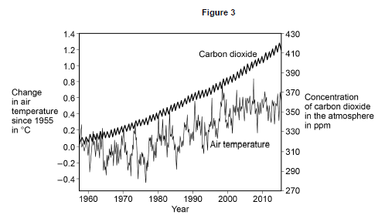
Evaluate evidence for and against the theory that an increase in the concentration of
carbon dioxide in the atmosphere causes an increase in air temperature.
Use data from Figure 3 and your own knowledge. (4)
………………………………………………………………………………………………………………………………………………………
………………………………………………………………………………………………………………………………………………………
………………………………………………………………………………………………………………………………………………………
………………………………………………………………………………………………………………………………………………………
………………………………………………………………………………………………………………………………………………………
………………………………………………………………………………………………………………………………………………………
………………………………………………………………………………………………………………………………………………………
………………………………………………………………………………………………………………………………………………………
………………………………………………………………………………………………………………………………………………………
………………………………………………………………………………………………………………………………………………………
………………………………………………………………………………………………………………………………………………………

4. Microorganisms cause infections.
In 2014 the Ebola virus killed almost 8 000 people in Africa.
Drug companies have developed a new drug to treat Ebola.
Explain what testing must be done before this new drug can be used to treat people. (6)
………………………………………………………………………………………………………………………………………………………
………………………………………………………………………………………………………………………………………………………
………………………………………………………………………………………………………………………………………………………
………………………………………………………………………………………………………………………………………………………
………………………………………………………………………………………………………………………………………………………
………………………………………………………………………………………………………………………………………………………
………………………………………………………………………………………………………………………………………………………
………………………………………………………………………………………………………………………………………………………
………………………………………………………………………………………………………………………………………………………
………………………………………………………………………………………………………………………………………………………
………………………………………………………………………………………………………………………………………………………
………………………………………………………………………………………………………………………………………………………
………………………………………………………………………………………………………………………………………………………
………………………………………………………………………………………………………………………………………………………
………………………………………………………………………………………………………………………………………………………
………………………………………………………………………………………………………………………………………………………
………………………………………………………………………………………………………………………………………………………
………………………………………………………………………………………………………………………………………………………

Total mark:

/23

